**Lesson 2 Accessing Data Homework**

Upload the 2 given files in the casuser folder by using the **Upload files** functionality as you can see :

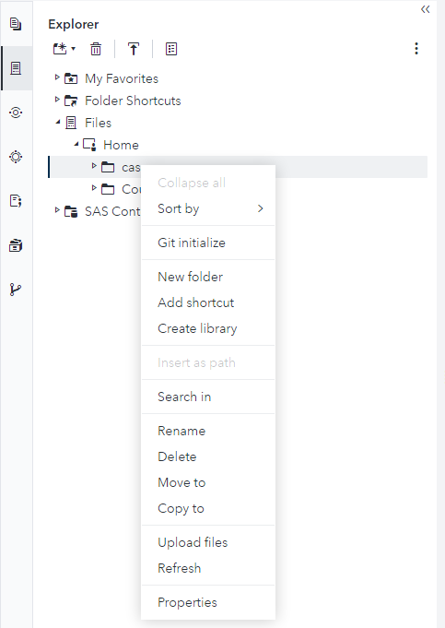

After succesfully uploading the 2 files, please correctly access them by using 1 of the 2 methods discussed during the course(Using libraries or PROC IMPORT)

**After doing so upload the code and a screen shot of the result of the code.**